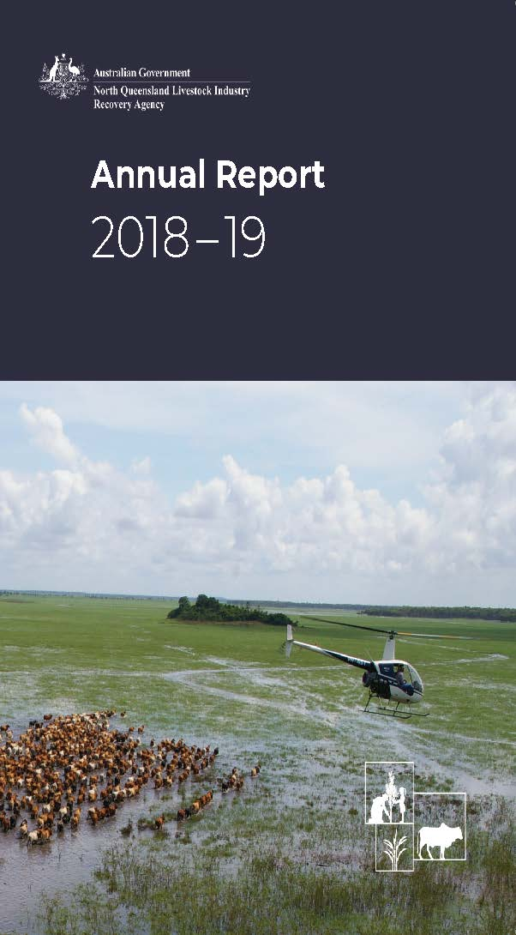

# Cow bones in the dirt.

# Mitchell grass against the blue sky. ABOUT THIS REPORT

This report outlines the operations and performance of the North Queensland Livestock Industry Recovery Agency (NQLIRA) for the financial year ending   
30 June 2019. It has been prepared in accordance with the provisions of section 46 of the *Public Governance, Performance and Accountability Act 2013* (PGPA Act), the *Public Governance, Performance and Accountability Rule 2014* (PGPA Rule) and the Department of Finance Resource Management Guide Number 135. The compliance index in Appendix B lists the information required by the PGPA Act and PGPA Rule and the corresponding page number within this report. Online versions are on the NQLIRA website ([www.nqlira.gov.au](http://www.nqlira.gov.au)) and [www.transparency.gov.au](http://www.transparency.gov.au).

ISSN: 2652-3337       (Print)

ISSN: 2652-3345       (Online) © Commonwealth of Australia 2018

### Creative Commons by Attribution 4.0 International licence

With the exception of the Commonwealth Coat of Arms, this work is licensed under a Creative Commons Attribution 4.0 International licence (CC BY 4.0) (https://creativecommons.org/licenses/by/4.0/).

The licence is a standard form licence agreement that allows the copying, distribution, transmission and adaptation of this publication provided it is attributed to this publication.

### THIRD PARTY COPYRIGHT

Wherever a third party holds copyright in this material, the copyright remains with that party. Their permission may be required to use the material. Please contact them directly.

### ATTRIBUTION

This publication should be attributed as follows:

© Commonwealth of Australia, North Queensland Livestock Industry Recovery Agency, Annual Report 2018–19.

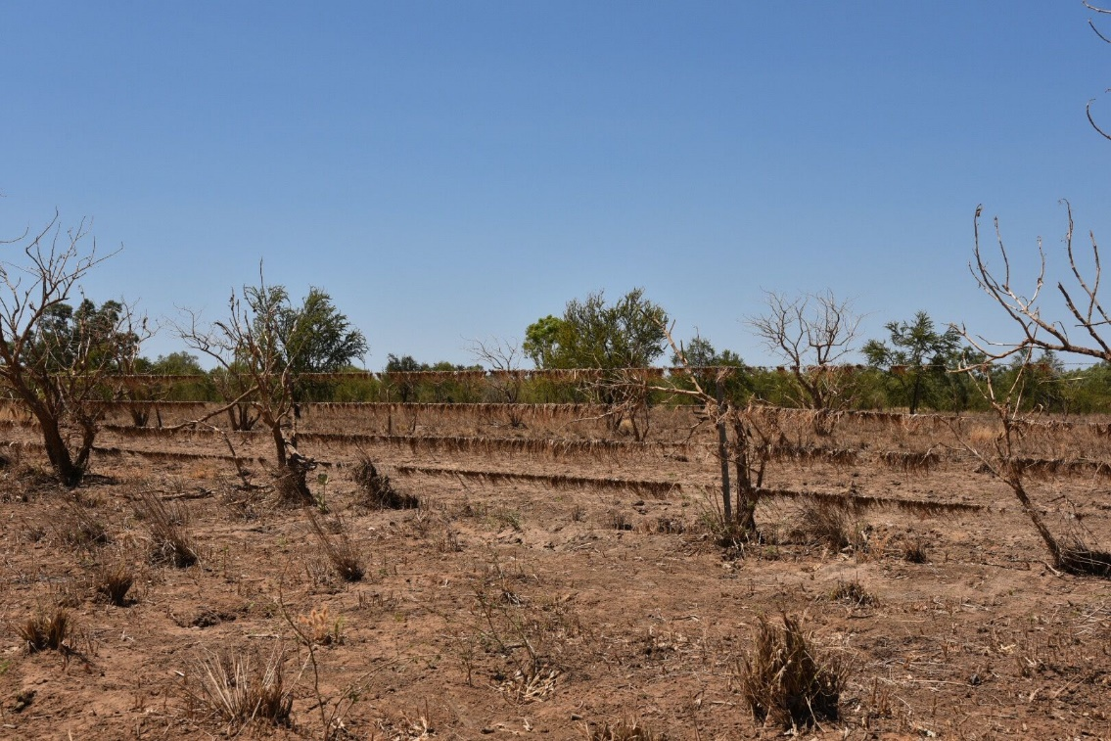**CONTACT US**

North Queensland Livestock Industry Recovery Agency

P.O. Box: 6500 Canberra ACT 2600 Australia

Internet: www.nqlira.gov.au

Email: nqlira@pmc.gov.au

Telephone: +61 2 6125 3351 (international)

Annual Report Contact Officer: Assistant Director Corporate

Contents

Letter of Transmittal 5

CEO’s Review 6

Introduction 13

Part 1: Agency Overview 14

Overview 15

Purpose 16

Outcome and Programs 16

Role and Functions 17

Operating Context 18

NQLIRA Executive 22

Human Resource Management 25

Employment Arrangements 26

Capability Development 26

Work Health and Safety 27

Executive Remuneration 28

Organisation Structure as at 30 June 2019 29

Management and Accountability & Other Mandatory Information 30

Part 2: Financial Statements 31

Independent Audit Report 33

Statement by the Chief Executive Officer and Chief Financial Officer 35

Primary Financial Statements 36

Appendix A: Index of Compliance 45

Glossary of Acronyms 53

Alphabetical Index 54

# Letter of Transmittal

The Hon. Scott Morrison MP
Prime Minister of Australia
PO Box 6022
House of Representatives
Parliament House
CANBERRA  ACT  2600




Dear Prime Minister


As the accountable authority of the North Queensland Livestock Industry Recovery Agency (Agency), I am pleased to present to you the 2018-19 NQLIRA Annual Report (the report), as required under section 46(1) of the Public Governance, Performance and Accountability Act 2013 (PGPA Act).   

The report addresses the period between the date of establishment of the Agency as a non corporate Commonwealth entity under the PGPA Act and the end of the 2018-19 reporting period (2 March through 30 June 2019). 

The report has been prepared in accordance with the mandatory requirements of section 46 of the PGPA Act, the content requirements of 17AA -17AJ of the Public Governance, Performance and Accountability Rule 2014 and includes the Agency’s audited financial statements, as required by Section 43(4) of the PGPA Act.





Yours sincerely


 


The Hon. Shane L Stone AC QC
14 October 2019



# CEO’s Review

The North Queensland Livestock Industry Recovery Agency (the Agency) was established by the Australian Government as a commitment to stand by North Queenslanders, and to honour the strength of their spirit, especially in times of extreme hardship.

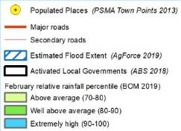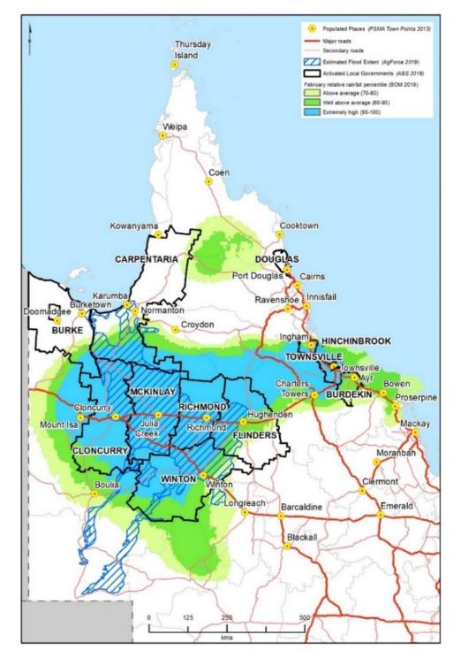As the North and Far North Queensland Monsoon Trough took hold from 25 January to 14 February 2019, flooding rains, low temperatures, constant winds and a wall of water more than 700km long devastated the North and North West regions of Queensland. The devastation extended from Burke Shire in the west, Winton in the south and as far east as Townsville on the coast of the Coral Sea.

*Map of affected regions of North, North West and Far North Queensland*

The region suffered catastrophic and unprecedented losses, totalling an estimated $5.68 billion in social and economic costs. This included several hundred thousand livestock lost, and damage to critical infrastructure such as roads and fences (some 6,420km of state roads, 15,000km of on farm roads and 10,000km of fencing). The flow on effects to local businesses, communities, economies and the environment were, and remain, significant.

In response, on 1 March 2019 Prime Minister Scott Morrison announced the creation of the Agency and appointed me as its Chairman and CEO. The Agency was charged with coordinating the immediate response to the floods making sure farmers, their families, small businesses and communities were receiving the support they needed to respond to this devastating event, and begin the long and steady road to recovery.

The Agency’s guiding principle is, and will remain:

***“locally led, locally understood and locally implemented”***

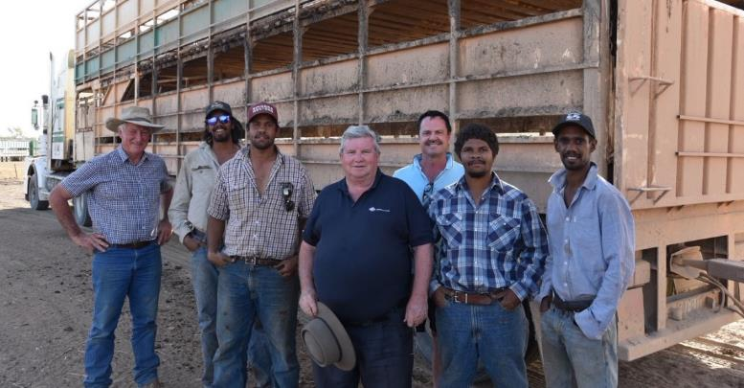I’m pleased to say that we hit the ground running. Within a fortnight of the announcement, Agency staff and I were on the road visiting Cloncurry, McKinlay and Julia Creek. We spoke to primary producers, community organisations, industry bodies and Queensland and local government representatives to make sure we were reaching the affected people in the shortest possible time.

*Shane Stone and Advisory Board members Don Heatley and David Galvin, with Gerald Aplin, Lleyton Toby, Tristan Toby and Javan Ah-wing at Lawn Hill Station*

From the day the Agency was created to 30 June 2019, Agency staff had travelled over 10,000km, spending approximately one third of the time on the ground promoting a range of Commonwealth grant and loan programs and visiting properties in the most affected regions to hear firsthand what impacted individuals and communities needed.

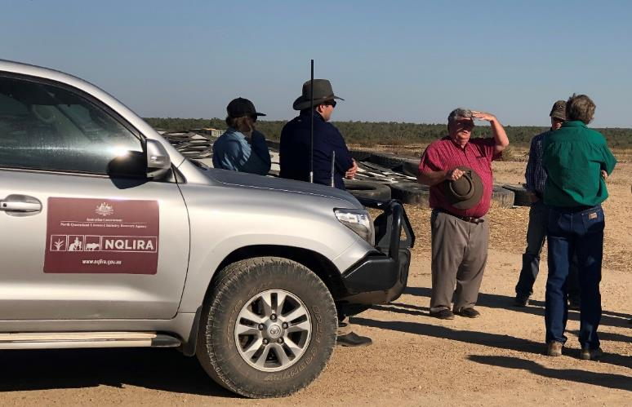

*Shane Stone with NQLIRA staff and local graziers a “Silver Hills,” Richmond*

We didn’t just listen, we also acted, providing access to over $318 million in Australian Government grants and funding, an important ‘hand up’ to individuals, primary producers, small businesses and non‑profit organisations across North Queensland.

Despite its name, the Agency’s remit extends beyond livestock to the full impact of the flood event, encompassing all primary production, small businesses and community considerations ranging from mental health to the environment, education and infrastructure, with respect to immediate needs and longer term recovery and strengthened resilience.

To support its complex and broad agenda the Agency is supported by an Advisory Board, whose members have extensive on the ground and industry experience, as well as experience in government and non‑government organisations.

During the reporting period the Board met several times, including in the affected regions of Townsville, Winton, Mossman and Cloncurry. Within a week of being re-elected, the Prime Minister met with the Board in Cloncurry, where he acknowledged its valuable contribution in providing advice to Government on how existing and new policies and programs could best support the recovery and reconstruction of the region.

*NQLIRA Advisory Board meeting co-chaired by*

*Prime Minister the Hon. Scott Morrison in Cloncurry, Queensland*

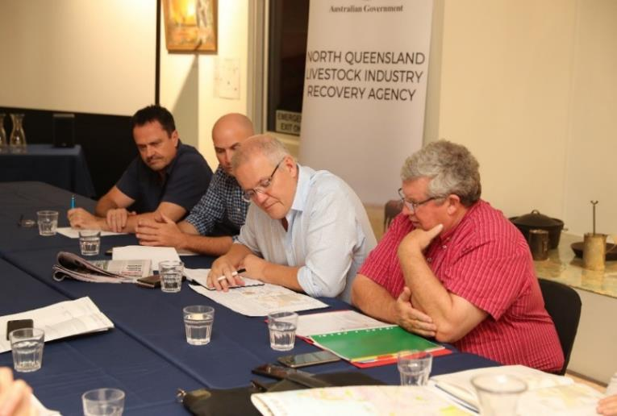

Within three months of its establishment, the Agency and the Commonwealth Department of Agriculture and Water Resources led the implementation of a $300 million grants program.

The Restocking, Replanting and On-farm Infrastructure grants of up to $400,000 (dollar for dollar) to assist primary producers who have suffered loss of livestock or damage to crops and infrastructure.

Stories of local producers like Emma and Andrew Forster in Winton, and Michael Bulley in Townsville, embody the human face of the region’s determination to pick themselves up and get back to business supporting themselves and their local communities. They are proof of how the Agency has assisted people and communities: by offering the right assistance at the right time.

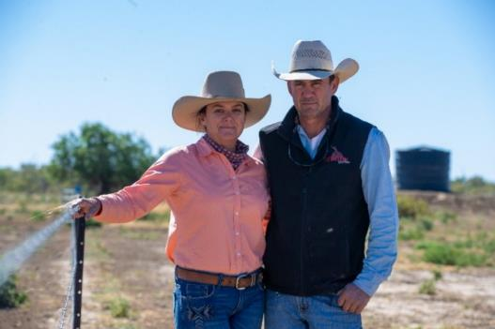Emma and Andrew lost 90 per cent of their cattle on one of their properties, and their on-farm road system was wiped out. Using the Government’s $75,000 grant for initial recovery and $400,000 grant for restocking, replanting and on‑farm infrastructure they are getting back to business:

*Emma and Andrew Forster, Winton*

*‘The quicker we can restock and get back into the cattle business the better, and it’s better for our community too. Once we can generate cash flow we can start spending money locally again.’*

In Townsville, Michael Bulley used the $50,000 grant provided to small businesses to clean up and refit his Donut King outlet. Without that support, his shop would probably not have reopened, and he’s grateful for the country’s “life changing” support when he needed it most.

It’s important that we continue to show Australians like Emma, Andrew and Michael that the country is behind them. The Agency has a five year life, and the work is far from over. The impacts of the event will continue to be felt over the next few years, particularly for primary producers and the businesses and communities that rely on them.

This annual report shows the rapid progress the Agency has made in our first four months, and lays out the important task ahead of rebuilding the region and strengthening its resilience to deal with a range of future events.

Following its initial efforts, the Agency shifted its focus to the timely development and implementation of a strategy for the long term recovery and strengthened resilience of North Queensland. This long term strategy will focus on locally led solutions that will help the region to be better informed and prepared for future natural disasters. We will consult widely to raise awareness of the potential to benefit from the strategy.

The Prime Minister has highlighted the Agency’s responsiveness, strong on the ground engagement and effective collaboration with the Queensland and local governments as making a crucial difference to the lives of those impacted by this unprecedented event, demonstrating that Government can be there for them when they need it most.

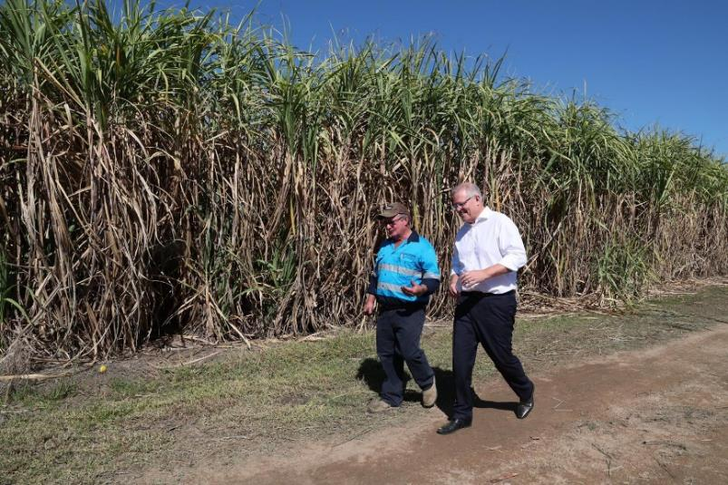

*Prime Minister the Hon. Scott Morrison with sugar cane grower Gary Stockham at his property in Giru, Queensland*

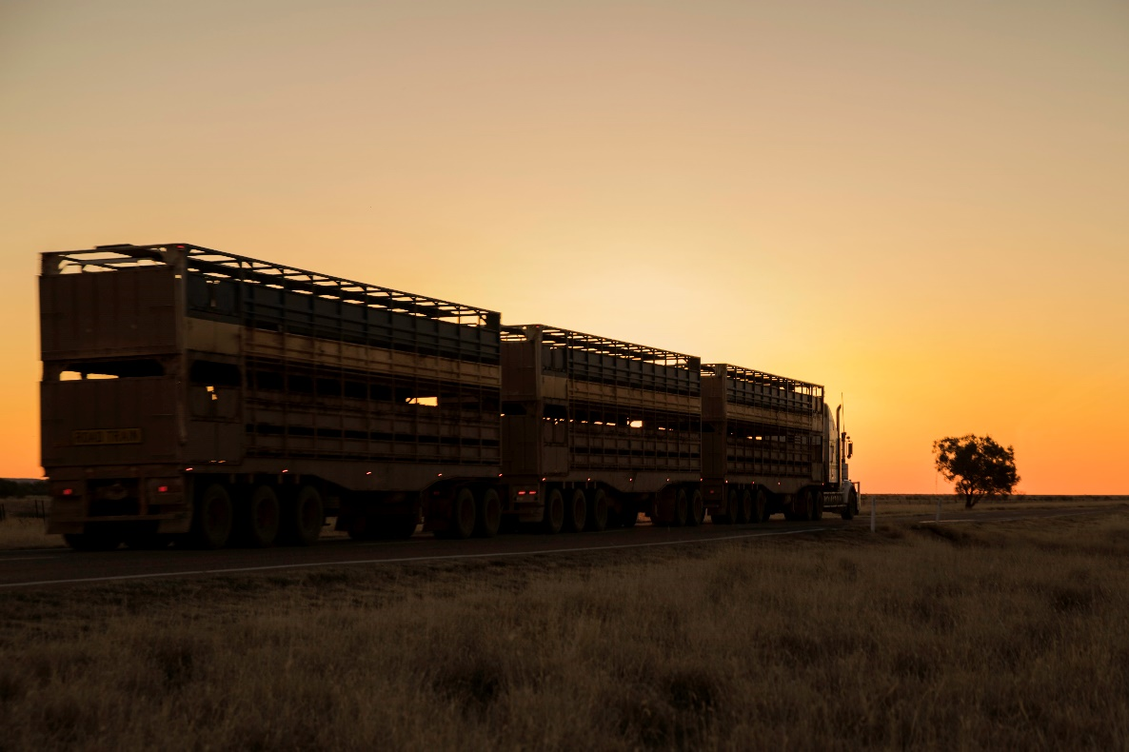

With over $3.3 billion committed to the immediate and longer term recovery of the flood impacted regions, the Agency is uniquely positioned to deliver strategic leadership and coordinate the Commonwealth’s contribution to North Queensland’s reconstruction, future resilience and prosperity.

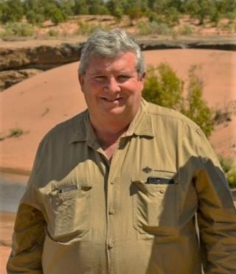It is with this compassionate and congestion-busting attitude that we will continue to have conversations around kitchen tables, in the shopfronts of small businesses, walk paddocks with farmers and stand by our communities as they rebuild and contribute to the country’s economy.

**The Hon. Shane L Stone AC QC**

Chief Executive Officer and Chairman

North Queensland Livestock Industry Recovery Agency

# 

# Introduction

I, as the accountable authority of the North Queensland Livestock Industry Recovery Agency (NQLIRA), present the 2018-19 NQLIRA Annual Report, which covers the period between the date of establishment of the Agency as a non‑corporate Commonwealth entity under the *Public Governance, Performance and Accountability Act 2013,* from 2 March to 30 June 2019 (the 2018-19 reporting period).

The NQLIRA Annual report has been prepared in accordance with the requirements of section 46 of the *Public Governance, Performance and Accountability Act 2013* and the content requirements of 17AA – 17AJ of the *Public Governance, Performance and Accountability Rule 2014.*

**The Hon. Shane L Stone AC QC**

Chief Executive Officer and Chairman

North Queensland Livestock Industry Recovery Agency

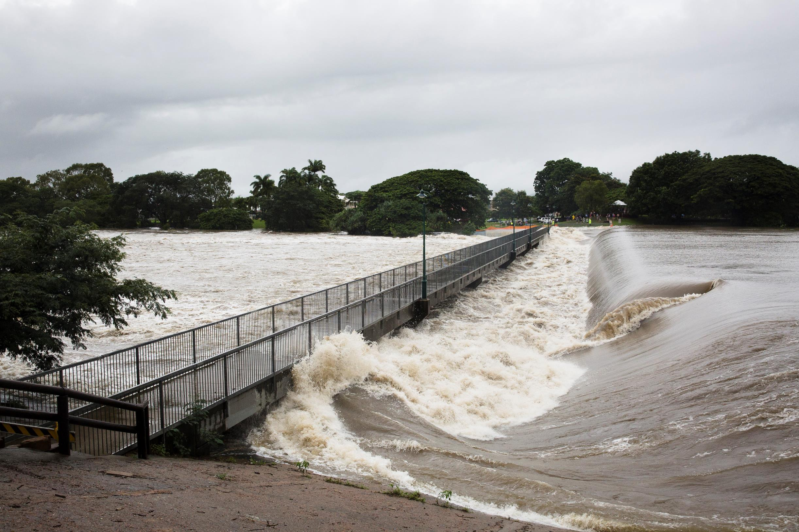Part 1:

Agency Overview

# Overview

On 2 March 2019 NQLIRA was established as a Non‑Corporate Commonwealth Entity, subject to the requirements of the *Public Governance, Performance and Accountability Act 2013 (PGPA Act)*.

NQLIRA was put in place by the Prime Minister to provide strategic leadership in response to the catastrophic and unprecedented event impacting North and Far North Queensland between 25 January ‑ 14 February 2019, referred to as the 2019 Monsoon Trough throughout this report. Affected regions experienced widespread flooding, low temperatures and high winds leading to the loss of hundreds of thousands of cattle, sheep and goats, degrading pastures and critically impacting the livelihoods and communities of the 11 affected Local Government Areas (LGAs) of Burdekin, Burke, Carpentaria, Cloncurry, Douglas, Flinders, Hinchinbrook, McKinlay, Richmond, Townsville and Winton.

NQLIRA was on the ground immediately, working with the affected communities and alongside delivery agencies. It also advised Government on how existing and new Commonwealth policies and programs could best contribute to the recovery and reconstruction efforts.

In the 122 days since its establishment, NQLIRA has provided timely, strategic leadership through the co-ordination of the Commonwealth’s recovery efforts to the affected regions. Agency staff worked collaboratively with affected communities, LGAs, the Queensland Government, Commonwealth Government agencies and the not‑for‑profit sector to identify and make available appropriate and effective assistance.

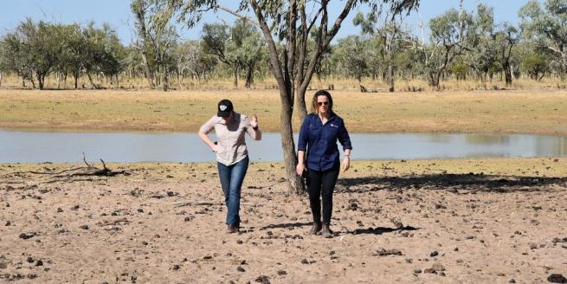

*NQLIRA staff Elyse Herrald-Woods and Laura Berthold, Normanton*

## Purpose

NQLIRA’s purpose is to coordinate and ensure the timely and effective delivery of the Commonwealth’s response to the North and Far North Queensland Monsoon Trough, and advise Government on long‑term recovery and resilience.

## Outcome and Programs

For the 2018-19 reporting period, NQLIRA operated as an independent taskforce within the Department of the Prime Minister and Cabinet. NQLIRA was not a recipient of a direct budgetary appropriation and, as such, was not subject to any specific Outcome and/or Program under the Commonwealth’s Budget and Reporting Framework.

Note to the Reader

*NQLIRA is expected to receive a direct budgetary appropriation in 2019 – 20. For Outcome and Program information beginning in the 2019 – 20 reporting period (the reporting period subsequent to the one in this report), please refer to* [*PRIME MINISTER AND CABINET PORTFOLIO, Portfolio Budget Statements 2019 – 20 Budget Related Paper No. 1.14 (North Queensland Livestock Industry Recovery Agency)*](https://www.pmc.gov.au/sites/default/files/publications/2019-20-pmc-pbs.pdf)*. Outcome and Program information for the 2019 – 20 reporting period will be reported in NQLIRA’s 2019 – 20 Annual Report.*

*Apiarist Blair Armstrong, Ayr*

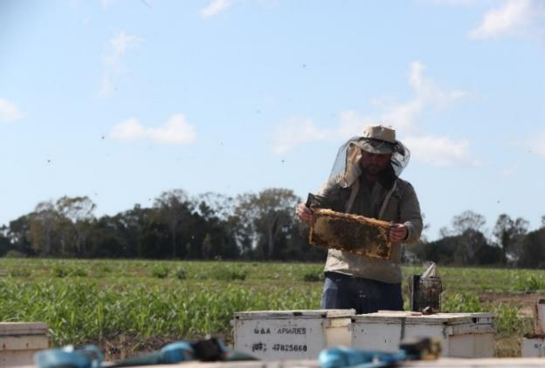

## Role and Functions

NQLIRA’s role is to assist with the immediate response, recovery and reconstruction efforts in support of the Queensland communities affected by the 2019 Monsoon Trough.

The functions of the Agency are to:

* 1. provide strategic leadership and co-ordination for the Commonwealth’s recovery and reconstruction activities in the flood affected areas of North, Far North and Western Queensland following the North and Far North Queensland Monsoon Trough (25 January – 14 February 2019);
  2. design, develop, consult on and coordinate the delivery of a long‑term plan for the recovery and reconstruction of these areas;
  3. build and maintain effective working relationships with stakeholders in these areas to inform recovery and reconstruction priorities;
  4. provide advice to the Prime Minister on how existing and new Commonwealth policies and programs can best contribute to the recovery and reconstruction efforts in these areas;
  5. provide a co-ordination point for information on associated Commonwealth recovery and reconstruction activities;
  6. provide advice to the Prime Minister on matters relevant to the North Queensland Livestock Industry Recovery Agency; and
  7. 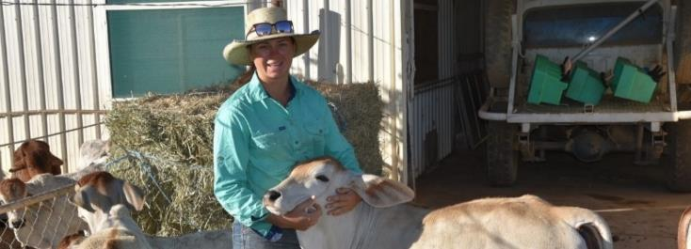undertake other relevant tasks as the Prime Minister may require from time to time.

*Elle Woodgate, Lawn Hill Station*

## Operating Context

Key to NQLIRA’s success in the 2018-19 reporting period was the extent to which it effectively worked with and alongside a wide range of other stakeholders - including service providers and governments at all levels - to coordinate the immediate response to the 2019 flood event, as well as laying the foundations for the ongoing recovery of the affected communities.

NQLIRA connected and supported the efforts of a range of Australian Government agencies to ensure a unified, targeted and effective delivery of Commonwealth support and assistance. The agencies involved in informing the immediate recovery and long‑term resilience efforts include:

* The Department of the Prime Minister and Cabinet;
* The Department of Agriculture;
* The Department of Environment and Energy;
* The Department of Health;
* The Department of Human Services;
* 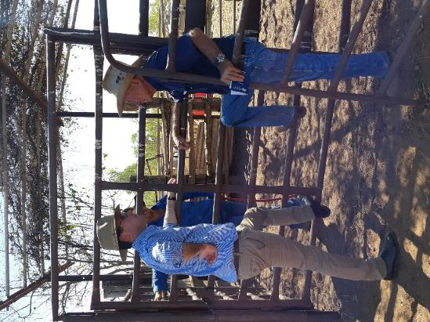The Department of Infrastructure;
* The Department of Regional Development and Cities;
* The Department of Social Services, Finance, the Treasury;
* The Department of Employment, Skills, Small and Family Business;
* The Bureau of Meteorology;
* Geoscience Australia;
* CSIRO; and
* Emergency Management Australia.

*The Hon. David Littleproud MP and grazier Mick Gallagher. Normanton*

NQLIRA also partnered with the Queensland Government, affected LGAs and communities to implement current Commonwealth initiatives including:

* The Queensland Department of the Premier and Cabinet;
* The Queensland Department of Agriculture and Fisheries;
* The Queensland Department of Environment and Sciences;
* The Queensland Department of Health;
* The Queensland Department of State Development, Manufacturing, Infrastructure and Planning;
* The Queensland Department of Natural Resources, Minerals and Energy;
* The Queensland Reconstruction Agency (QRA);
* The Queensland Rural and Industry Development Authority (QRIDA);
* The Shire of Burke;
* The Shire of Carpentaria;
* The Shire of Cloncurry;
* The Shire of McKinlay;
* The Shire of Richmond;
* The Shire of Flinders;
* The Shire of Winton;
* The Shire of Douglas;
* The Shire of Hinchinbrook;
* The Shire of Townsville; and
* The Shire of Burdekin.

Building and strengthening these relationships across all levels of government, as well as with communities and the private sector, assisted NQLIRA to gather evidence to inform government, thereby effectively targeting the Commonwealth’s response to the flood event.

*At the end of the day, NQLIRA can only succeed through establishing enduring and trustful bonds that foster collaboration with the people, communities and entities connected with this event.*

**Key Achievements in 2018-19**

* NQLIRA was successfully established as an Australian Government non‑corporate Commonwealth entity on 2 March 2019 to provide strategic leadership and co-ordination of the Commonwealth’s response to the 2019 flood event.
* Within weeks, NQLIRA successfully sourced and deployed a taskforce of skilled and experienced staff, drawing together a workforce with a diverse skill base and expert knowledge.
* NQLIRA successfully built working relationships with the affected communities, primary producers, states and local governments to raise awareness of the immediate support available and to gather invaluable information to shape the short and longer term response.
  + Between 2 March and 30 June 2019, NQLIRA hosted 36 events and individually met and consulted with numerous landholders, local officials, businesses, charities and other stakeholders from flood affected communities across North Queensland.
  + The CEO and Agency staff met with the Mayors of the 11 of the affected LGAs. It is estimated that Agency staff spent more than a third of the time since the Agency was formed in affected communities. Having a presence in these communities is essential to developing solutions which are locally led, locally understood and locally implemented.
* NQLIRA successfully advised the Government on the co‑ordination of the Commonwealth’s response and supported eligible people to access:
  + Over $80 million in assistance to primary producers via Special Disaster Assistance Recovery Grants;
  + $300 million of Restocking, Replanting & On-farm Infrastructure Grants;
  + Over $9 million in assistance to small businesses and not‑for‑profit organisations via Special Disaster Assistance Recovery Grants;
  + Over $100 million in assistance via the Disaster Recovery Payment and Disaster Recovery Allowance;
  + $121 million in assistance provided to the Queensland Government under the Disaster Recovery Funding Arrangements;
  + $4 million in assistance to independent schools with significant numbers of students from flood affected areas;
  + $2.6 million in assistance to support the mental health of communities affected by the floods; and
  + AgRebuild Loans, through the Regional Investment Corporation, to help flood affected primary producers restock, replant and recover.

**For more information on NQLIRA’s key achievements, visit** [**www.nqlira.gov.au**](http://www.nqlira.gov.au)**.**

### 

### Public Governance, Performance and Accountability Act 2013 Report on Performance

For the 2018-19 reporting period (2 March to 30 June 2019) NQLIRA operated as a taskforce hosted within the Department of the Prime Minister and Cabinet. NQLIRA did not receive a direct budgetary appropriation and did not have any specific financial or non‑financial performance information.

All NQLIRA’s financial and non‑financial performance reporting (for the purpose of section 17AD(c) Public Governance, Performance and Accountability Rule 2014 – Report on Performance) is encompassed within the operations and reporting of the Department of the Prime Minister and Cabinet.

For Performance information beginning in the 2019 – 20 reporting period (the reporting period subsequent to the one in this report) readers should refer to the [NQLIRA Corporate plan 2019 – 20 to 2022 – 23](https://www.nqlira.gov.au/resources) and [PRIME MINISTER AND CABINET PORTFOLIO, Portfolio Budget Statements 2019 – 20 Budget Related Paper No. 1.14 (North Queensland Livestock Industry Recovery Agency)](https://www.pmc.gov.au/sites/default/files/publications/2019-20-pmc-pbs.pdf). All Financial and non – financial performance for the 2019 – 20 reporting period will be reported against in NQLIRA’s 2019 – 20 Annual Report.

## NQLIRA Executive

NQLIRA is led by the Chief Executive Officer, the Hon. Shane L Stone AC QC.

## NQLIRA Chief Executive Officer and Chairman

### Shane Stone wearing a suit and tie, looking at the camera. The Honourable Shane L Stone AC QC

Accountable Authority, Chief Executive Officer and Chairman from 2 March 2019.

Shane Stone is the founding head of the North Queensland Livestock Industry Recovery Agency. Shane is currently the Chief Executive Officer of the Agency and the Accountable Authority of the entity under the *Public Governance, Performance and Accountability Act 2013*. Shane’s appointment to lead NQLIRA represents another significant chapter in a life dedicated to public service.

As the former Chief Minister of the Northern Territory he served in the Northern Territory Legislative Assembly for almost 10 years. He had a close working relationship with the NT cattle industry over this time. In 2014 Mr Stone was appointed Chairman of the Northern Australian Advisory Group by then Prime Minister Tony Abbott. He also contributed to the Royal Commission into the Australian Meat Industry in 1982.

Having grown up in Wodonga on the NSW/Victorian border Mr Stone understands the quiet strength of country Australians who work hard to give their families a decent life and look out for each other in the good and not‑so‑good times. He believes a person should be regarded for their deeds and not their possessions, an ethos that has guided him personally and professionally.

As the CEO and Chairman of the North Queensland Livestock Industry Recovery Agency, Shane reports directly to the Prime Minister and is supported by an Advisory Board comprising representatives from the northern cattle industry, affected communities, and local and Federal government.

**NQLIRA Advisory Board**

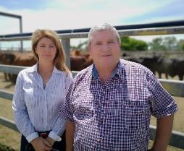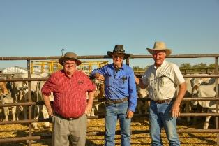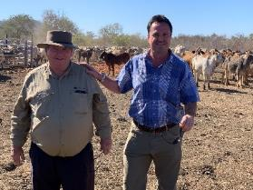The Advisory Board comprises members with on the ground livestock industry experience, as well as experience in government and non‑government organisations. The Board plays a vital role in providing expert advice to NQLIRA.

*Shane Stone and Tracey Hayes, Townsville*

**NQLIRA Advisory Board Members**

*Shane Stone and David Galvin, Mt Surprise Station*

*Shane Stone, Rodger Jefferis and Don Heatley at “Elrose”, Cloncurry*

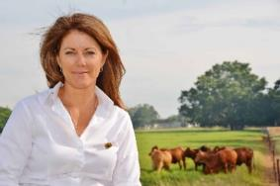Tracey Hayes is a former pastoralist, and has spent her lifetime working in the northern beef industry. Tracey is a former Chief Executive Officer of the Northern Territory Cattlemen’s Association, a member of the Council for the Order of Australia, a Director on the Board of the Australia Indonesia Institute and a member of the Board of the Cooperative Research Centre for Developing Northern Australia. Tracey has been a passionate industry advocate for many years, with a strong interest in agribusiness, agri‑politics and championing women in leadership.

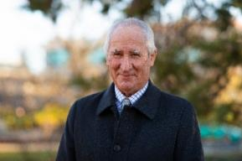Don Heatley OAM is a fifth generation North Queensland cattle farmer, and is the Chair of the Australian Centre for International Agricultural Research Commission. Don is a passionate and committed advocate for the promotion of Australian agribusiness interests overseas and for investing in the strengthening of domestic agribusiness in developing countries. Don has more than 30 years’ experience promoting the Australian beef industry internationally, including as former chairman of Meat and Livestock Australia and through roles on state livestock councils and the Cattle Council of Australia.

**Greg Campbell is the Mayor of Cloncurry Shire Council. Greg and his family also operate a beef cattle business, based on two properties in the McKinlay district. Greg is an active member of the Cloncurry community, and sits on a number of committees in the area. He is Deputy Chair of the North West Regional Roads Group, and an executive committee member of the Mount Isa to Townsville Economic Zone. Greg also serves as a committee member of the LGAQ Resource Communities Advisory Committee, and is a member of Regional Development Australia Townsville North West.

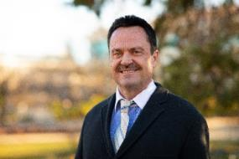David Galvin is the former chair of the Australian Livestock Export Corporation (Livecorp) and has extensive experience in the northern pastoral industry, land management, infrastructure and tourism development. David served as Chief Executive Officer (CEO) of the Indigenous Land Corporation (ILC) from 2001 to 2012, when the ILC was in the top ten largest cattle producers in Australia. He is an independent Director of the Australian Livestock Exporters’ Council, non‑member Director of the Aboriginal Medical Services Alliance Northern Territory (chair of the Audit and Risk Committee), an Advisory Board Member of Paga Hill Development Company in Papua New Guinea, Managing Director of Tubarao Investments Pty Ltd and on the Executive Committee of the Queensland Livestock Export Association.

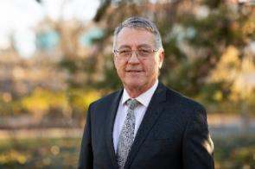Daryl Quinlivan is the Secretary of the Department of Agriculture. Daryl is a career public servant who was the Head of Office at the Productivity Commission before his appointment as Secretary of the Department in 2015. Daryl previously worked in the former Department of Agriculture, Fisheries and Forestry from 1999 to 2010 as both a Deputy Secretary and First Assistant Secretary. He then joined the Department of Broadband, Communications and the Digital Economy as a Deputy Secretary before moving to the Productivity Commission in 2012.

Human Resource Management

NQLIRA had one employee during 2018-19, the Chief Executive Officer (CEO).

NQLIRA was supported by a taskforce hosted within the Department of the Prime Minister and Cabinet, funded by an appropriation provided directly to the Department for the establishment and operation of the Agency. Secondees were recruited to the taskforce from a number of Commonwealth agencies (refer to table below) reaching an Average Staffing Level (ASL) of 25 at 30 June 2019. To ensure continuity in delivering outcomes and setting up NQLIRA, 13 secondments were extended and will remain with the Department of the Prime Minister and Cabinet until early 2020.

***Secondees and non‑going staff as at 30 June 2019:***

|  |  |  |
| --- | --- | --- |
| Agency | Staffing Numbers | Substantive Classification at 30 June 2019 |
| Australian Office of Financial Management (AOFM) | 1 | Executive Level 2 |
| Clean Energy Regulator | 1 | Executive Level 2 |
| Department of Agriculture | 7 | SES Band 2, SES Band 1. Executive Level 2 (three), APS 6, APS5 |
| Department of Industry, Innovation & Science | 1 | Executive Level 2 |
| Department of Human Services | 1 | Executive Level 2 |
| Department of Employment/Jobs | 1 | Executive Level 1 |
| Department of Defence | 2 | Executive level 1, APS 6 |
| Department of Environment | 1 | Executive Level 2 |
| Department of Finance | 1 | SES Band 1 |
| Department of the Prime Minister & Cabinet | 3 | SES Band 1, Executive Level 1, APS 6 |
| Geoscience Australia | 2 | Executive Level 2, APS 5 |
| Non – Ongoing Employment Contract | 4 | Executive Level 1, APS 6, APS 5 (two) |

## 

## Employment Arrangements

All secondees remain employees of their home Commonwealth agency. SES officers are employed under the terms of individual determinations made under section 24(1) of the Public Service Act 1999 with their home agencies. All staff, except the CEO, were based in Canberra. Staff will be transitioned to the Agency following the passage of the *2019 – 20 Appropriation Act (No.1) 2019-20.*

Note to the Reader

NQLIRA has prepared a determination under section 24(1) of the *Public Service Act 1999*. This determination provides the terms and conditions of employment for non‑SES employees of the Agency. It was developed as an interim instrument for non‑SES employees until NQLIRA negotiates and implements an Agency Enterprise Agreement. There were no staff employed under this determination during the 2018-19 reporting period.

## Capability Development

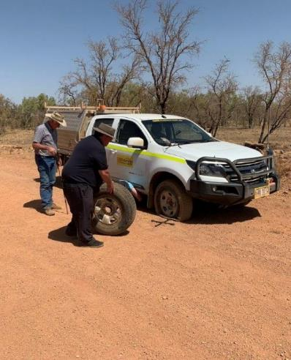NQLIRA is committed to the personal and professional development of all secondees. From 2 March to 30 June 2019, secondees had access to the Department of the Prime Minister and Cabinet’s capability development opportunities. Opportunities included formal training and study, networking events and conferences and a range of in‑house delivered training and information sharing sessions.

All secondees also completed:

* a range of eLearning modules including Work Health & Safety and Fraud;
* accredited Introductory and Remote First Aid Training; and
* accredited 4WD vehicle training.

*Another day on the road, NW Queensland*

## 

## Work Health and Safety

NQLIRA is committed to providing a safe workplace for all employees. The Agency recognises the importance of its legislative obligations under the *Work Health and Safety Act 2011* to prevent work related injury and illness. For the 2018-19 reporting period, NQLIRA operated within the Work Health and Safety policy and procedures of the Department of the Prime Minister and Cabinet.

As a part of its commitment to providing a safe working environment, NQLIRA has also:

* embedded a focus on Work Health and Safety (WHS) in its governance practices, including as a standing agenda in its executive meetings;
* developed WHS policies, procedures and guidance material relevant to remote and rural travel;
* promoted the use of health and wellbeing services for secondees through the Department of the Prime Minister and Cabinet employee assistance program;
* utilised ergonomically appropriate workstation equipment, including sit/stand desks and dual monitors;
* provided voluntary influenza, Q Fever and tetanus vaccinations; and
* provided specific WHS training (as detailed above).

From 2 March to 30 June 2019, there were no notifiable incidents that required reporting to Comcare, no directions or notices given to NQLIRA, and no WHS investigations. NQLIRA had no active workers compensation claims as at 30 June 2019.

## Executive Remuneration

The Hon. Shane Stone AC QC is employed via a determination made under section 67 of the *Public Service Act 1999*.

The CEO’s remuneration is independently determined by the Remuneration Tribunal. For more information please see: <https://www.remtribunal.gov.au/>

***Information about remuneration for key management personnel 2018-19.***

|  |  |  |
| --- | --- | --- |
| Name | | The Hon. Shane L Stone AC QC |
|  | Position title | Chief Executive Officer |
| Base salary | $183,289 |
| Short – term benefits | Bonuses | – |
| Other benefits and allowances | – |
| Post – employment benefits | Superannuation contributions | $9,331 |
| Other long – term benefits | Long service leave | – |
| Other long – term benefits | $1,830 |
| Termination benefits | Termination benefits | – |
| Total remuneration | | $194,449 |

*Note: Figures reported in the table above represent the total remuneration entitlement provided within the 2018‑19 reporting period, between the establishment of NQLIRA and the end of the reporting period (2 March 2019 to 30 June 2019). For further information please refer to Part 2: Financial Statements (Note A: Expenses and Note C: Employee Provisions).*

## Organisation Structure as at 30 June 2019

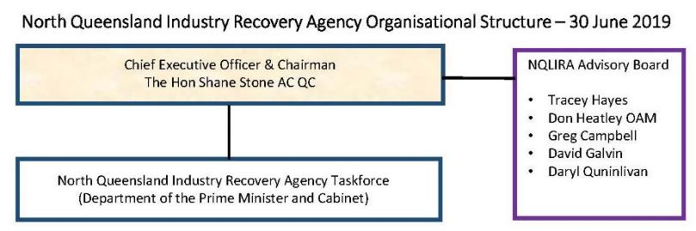

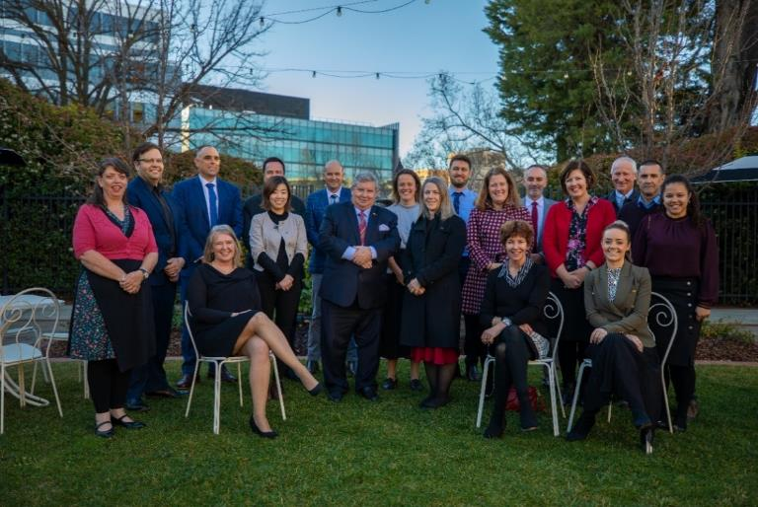

*Shane Stone with NQLIRA Taskforce Staff and NQLIRA Advisory Board Members*

# Management and Accountability & Other Mandatory Information

For the 2018-19 reporting period, NQLIRA operated as a taskforce hosted within the Department of the Prime Minister and Cabinet.

NQLIRA did not receive a direct budgetary appropriation. Its activities were funded by an appropriation provided to the Department of the Prime Minister and Cabinet, which enabled the establishment of a taskforce within the Department. As taskforce personnel were Department of the Prime Minister and Cabinet secondees, utilising a Department of the Prime Minister and Cabinet appropriation, their actions and operations were subject to the operational requirements, governance, financial controls, management and accountability arrangements of the Department of the Prime Minister and Cabinet.

During the 2018-19 reporting period, NQLIRA did not undertake any activities independently of the Department of the Prime Minister and Cabinet.

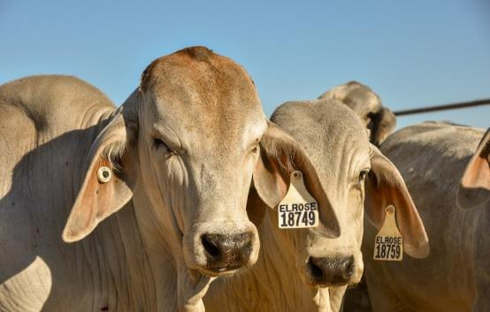As such, the non-corporate Commonwealth entity reporting requirements as per section 17AD(d) – Management Accountability and 17AD(f) Other Mandatory information of the *Public Governance, Performance and Accountability Rule 2014* are encompassed within the operations and reporting of the Department of the Prime Minister and Cabinet.

*Cattle at “Elrose” Brahman Stud, Cloncurry*

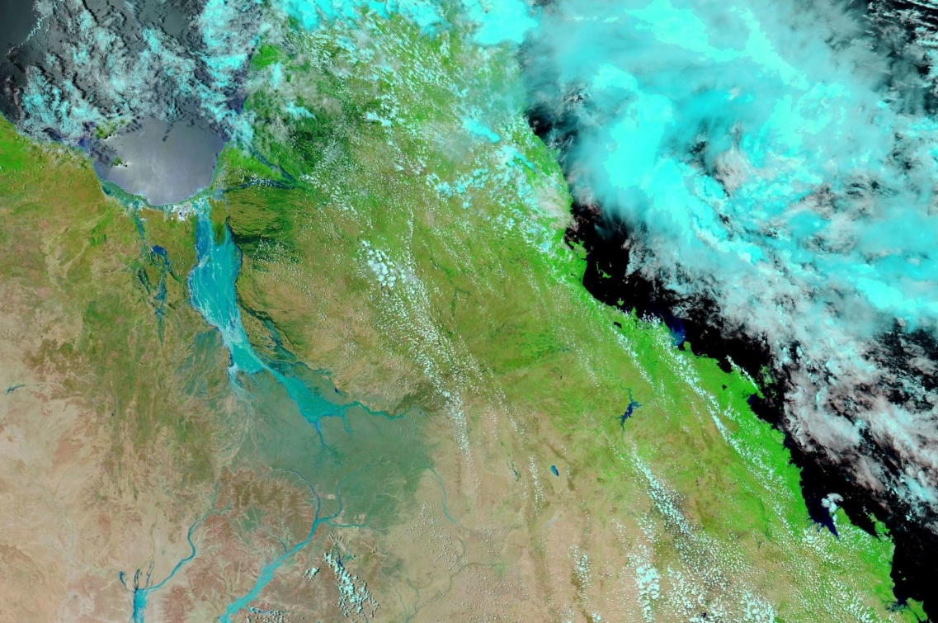

# Part 2: Financial Statements

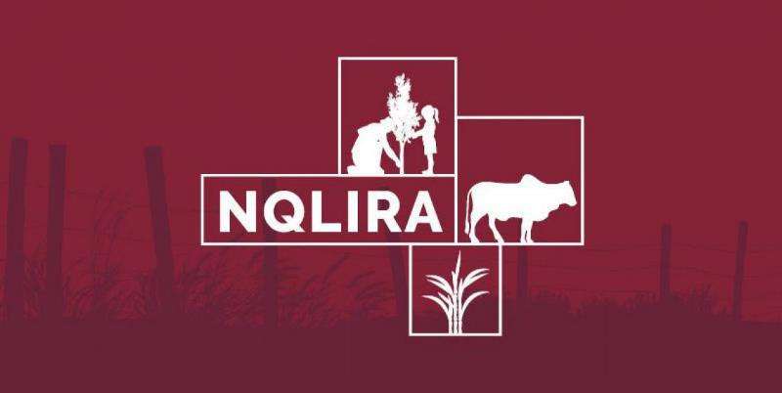

Financial Statements

**Independent Audit Report 33**

**Statement by the Chief Executive Officer and Chief Financial Officer 34**

**Primary Financial Statements 35**

Statement of comprehensive income 35

Statement of financial position 36

Statement of changes in equity 37

Statement of cash flows 37

**Notes to Financial Statements 38**

Entity Overview 39

Basis of Preparation Of The Financial Statements 40

Note A: Expenses 40

Note B: Revenues 42

Note C: Employee provisions 43

Note D: Budgetary report to outcome comparison 44

# Independent Audit Report


INDEPENDENT AUDITOR’S REPORT
To the Prime Minister
Opinion
In my opinion, the financial statements of the North Queensland Livestock Industry Recovery Agency (‘the
Entity’) for the period ended 30 June 2019:
(a) comply with Australian Accounting Standards – Reduced Disclosure Requirements and the Public
Governance, Performance and Accountability (Financial Reporting) Rule 2015; and
(b) present fairly the financial position of the Entity as at 30 June 2019 and its financial performance and cash
flows for the period then ended.
The financial statements of the Entity, which I have audited, comprise the following statements as at 30 June
2019 and for the period then ended:
• Statement by the Accountable Authority and Chief Finance Officer;
• Statement of Comprehensive Income;
• Statement of Financial Position;
• Statement of Changes in Equity; and
• Notes to the financial statements, comprising a Summary of Significant Accounting Policies and other
explanatory information.
Basis for opinion
I conducted my audit in accordance with the Australian National Audit Office Auditing Standards, which
incorporate the Australian Auditing Standards. My responsibilities under those standards are further described
in the Auditor’s Responsibilities for the Audit of the Financial Statements section of my report. I am independent
of the Entity in accordance with the relevant ethical requirements for financial statement audits conducted by
the Auditor-General and his delegates. These include the relevant independence requirements of the
Accounting Professional and Ethical Standards Board’s APES 110 Code of Ethics for Professional Accountants (the
Code) to the extent that they are not in conflict with the Auditor-General Act 1997. I have also fulfilled my other
responsibilities in accordance with the Code. I believe that the audit evidence I have obtained is sufficient and
appropriate to provide a basis for my opinion.
Accountable Authority’s responsibility for the financial statements
As the Accountable Authority of the Entity, the Chief Executive Officer is responsible under the Public
Governance, Performance and Accountability Act 2013 (the Act) for the preparation and fair presentation of
annual financial statements that comply with Australian Accounting Standards – Reduced Disclosure
Requirements and the rules made under the Act. The Chief Executive Officer is also responsible for such internal
control as the Chief Executive Officer determines is necessary to enable the preparation of financial statements
that are free from material misstatement, whether due to fraud or error.
In preparing the financial statements, the Chief Executive Officer is responsible for assessing the ability of the
Entity to continue as a going concern, taking into account whether the Entity’s operations will cease as a result
of an administrative restructure or for any other reason. The Chief Executive Officer is also responsible for
disclosing, as applicable, matters related to going concern and using the going concern basis of accounting unless
the assessment indicates that it is not appropriate.


Auditor’s responsibilities for the audit of the financial statements
My objective is to obtain reasonable assurance about whether the financial statements as a whole are free from material misstatement, whether due to fraud or error, and to issue an auditor’s report that includes my opinion. Reasonable assurance is a high level of assurance, but is not a guarantee that an audit conducted in accordance with the Australian National Audit Office Auditing Standards will always detect a material misstatement when it exists. Misstatements can arise from fraud or error and are considered material if, individually or in the aggregate, they could reasonably be expected to influence the economic decisions of users taken on the basis of the financial statements.
As part of an audit in accordance with the Australian National Audit Office Auditing Standards, I exercise professional judgement and maintain professional scepticism throughout the audit. I also:
• identify and assess the risks of material misstatement of the financial statements, whether due to fraud or error, design and perform audit procedures responsive to those risks, and obtain audit evidence that is sufficient and appropriate to provide a basis for my opinion. The risk of not detecting a material misstatement resulting from fraud is higher than for one resulting from error, as fraud may involve collusion, forgery, intentional omissions, misrepresentations, or the override of internal control;
• obtain an understanding of internal control relevant to the audit in order to design audit procedures that are appropriate in the circumstances, but not for the purpose of expressing an opinion on the effectiveness of the Entity’s internal control;
• evaluate the appropriateness of accounting policies used and the reasonableness of accounting estimates and related disclosures made by the Accountable Authority;
• conclude on the appropriateness of the Accountable Authority’s use of the going concern basis of accounting and, based on the audit evidence obtained, whether a material uncertainty exists related to events or conditions that may cast significant doubt on the Entity’s ability to continue as a going concern. If I conclude that a material uncertainty exists, I am required to draw attention in my auditor’s report to the related disclosures in the financial statements or, if such disclosures are inadequate, to modify my opinion. My conclusions are based on the audit evidence obtained up to the date of my auditor’s report. However, future events or conditions may cause the Entity to cease to continue as a going concern; and
• evaluate the overall presentation, structure and content of the financial statements, including the disclosures, and whether the financial statements represent the underlying transactions and events in a manner that achieves fair presentation.
I communicate with the Accountable Authority regarding, among other matters, the planned scope and timing of the audit and significant audit findings, including any significant deficiencies in internal control that I identify during my audit.
Australian National Audit Office
Clea Lewis
Executive Director
Delegate of the Auditor-General
Canberra
26 September

# 

# Statement by the Chief Executive Officer and Chief Financial Officer

In our opinion, the attached financial statements for the year ended 30 June 2019 comply with subsection 42 (2) of the *Public Governance, Performance and Accountability Act 2013* (PGPA Act), and are prepared from properly maintained financial records as required by subsection 41 (2) of the PGPA Act.

The ability for the North Queensland Livestock Industry Recovery Agency (NQLIRA) to repay its debts as and when they fall due is subject to an appropriation by Parliament through *Appropriation Act (No.1) 2019 – 20* (the Act). At the date of this statement, the Act had not passed Parliament or received Royal Assent.

No matter, transaction or event of a material or unusual nature has arisen in the interval between the end of the reporting period (30 June 2019) and the date of signing this report that has significantly affected or may significantly affect NQLIRA’s operations.

|  |  |
| --- | --- |
| Signed | Signed |
|  |  |
| The Hon. Shane L. Stone AC QC | Samantha Montenegro |
| Chief Executive Officer | Chief Financial Officer |
| 26 September 2019 | 26 September 2019 |

# Primary Financial Statements

### North Queensland Livestock Industry Recovery Agency

## Statement of comprehensive income ($’000)

##### for the period ended 30 June 2019



The above statement should be read in conjunction with the accompanying notes.

### North Queensland Livestock Industry Recovery Agency

## Statement of financial position ($’000)

##### as at 30 June 2019



The above statement should be read in conjunction with the accompanying notes.

##### Liabilities expected to be settled in (‘000)



There are no quantifiable or unquantifiable departmental contingencies as of the signing date that may have an impact on NQLIRA’s operations.

### North Queensland Livestock Industry Recovery Agency

## Statement of changes in equity ($’000)

##### for the period ended 30 June 2019



### North Queensland Livestock Industry Recovery Agency

## Statement of cash flows ($’000)

##### for the period ended 30 June 2019

During financial year 2018-19, all establishment and operating activities were funded by the Department of Prime Minister and Cabinet (PM&C).

As such, no cash movements were recorded by NQLIRA and, therefore, no cash flow statement has been prepared.

# Notes to Financial Statements

## Entity Overview

The North Queensland Livestock Industry Recovery Agency (NQLIRA) was established on 2 March 2019, as an Executive Agency under Section 65 of the *Public Service Act 1999* (PS Act) and as a Non – Corporate Commonwealth Entity subject to the requirements of the *Public Governance, Performance and Accountability Act 2013* (PGPA Act)*.*

At the time of the announcement, the Prime Minister appointed the Hon. Shane L Stone AC QC as Chief Executive Officer. NQLIRA’s primary purpose is to coordinate and ensure the timely and effective delivery of the Commonwealth’s response, recovery and reconstruction efforts to those regions affected by the North, North West and Far North Queensland monsoon trough in January and February 2019, and to advise Government on long – term recovery and resilience.

During 2018-19, NQLIRA received no appropriation. The Department of Prime Minister and Cabinet (PM&C) received all relevant funding (both operating and capital) in relation to the establishment and activities of NQLIRA. NQLIRA did not have access or direct control over these appropriations, thus all expenditures incurred were funded as resource received free of charge from PM&C’s appropriation for NQLIRA. NQLIRA was supported by a taskforce established within PM&C that undertook establishment and engagement activities for NQLIRA.

## 

## Basis of Preparation Of The Financial Statements

These financial statements are general purpose financial statements and are required by section 42 of the PGPA Act.

The financial statements have been prepared in accordance with:

* *the Public Governance, Performance and Accountability (Financial Reporting) Rule 2015* (FRR); and
* Australian Accounting Standards and Interpretations – Reduced Disclosure Requirements issued by the Australian Accounting Standard Board (AASB) that apply for the reporting period.

The financial statements have been prepared on an accrual basis and in accordance with historical cost convention as required or allowable by relevant accounting standards. The financial statements are represented in Australian dollars and values are rounded as indicated.

## Note A: Expenses

##### Employee benefits ($’000)

The CEO is the only employee appointed on a permanent basis.

Total employee benefits reported reflect total remuneration of the CEO, who is reported as key management personnel for 2018-19 financial year.

##### Key Management Personnel (‘000)

Key Management Personnel (KMP) are those persons having authority and responsibility for planning, directing and controlling the activities of the entity, directly or indirectly. KMP for NQLIRA include the Prime Minister and Portfolio Ministers1, and the Chief Executive Officer (CEO).

Remuneration reported in this note excludes the remuneration and other benefits of the Prime Minister and Portfolio Ministers, as these were not paid by NQLIRA. The CEO is remunerated consistent with *Remuneration Tribunal (Remuneration and Allowances for Holder of Part – time Public Officer) Determination 2018*. All remuneration for financial year 2018-19 was funded by PM&C as resource received free of charge.

The following table sets out KMP remuneration (on an accruals basis):



## Note B: Revenues

No appropriations were made available to NQLIRA during 2018-19. As such, there was no appropriation reported by NQLIRA for the financial year 2018-19.

##### Special appropriations

Special appropriation – *Treasury Laws Amendment (North Queensland Flood Recovery) Act 2019* was enacted in April 2019 for an amount of $1.75 billion for the purpose of making loans to financial institutions under the program known as ‘Urgent assistance for eligible primary producers affected by floods in Northern Queensland’. The appropriation did not become available until 1 July 2019, thus was not reflected in the financial statements for 2018-19.

##### Other Income (‘000)



Resource received free of charge is recognised as revenue when and only when a fair value of goods and services provided can be reliably determined.

PM&C provided resources free of charge to NQLIRA during 2018-19 consistent with the expenses reported in the Supplier Expenses table in Note A: Expenses, excluding employee provisions recognised for the CEO.

## Note C: Employee provisions

Employee benefit expenses for NQLIRA are for the CEO, as the sole employee appointed on a permanent basis.

#### Leave

The liability for employee benefits includes provisions for annual leave and long service leave. No provision has been made for sick leave as sick leave is non vesting and the average sick leave taken in future years by employees is estimated to be less than the annual entitlement for sick leave.

The leave liability is calculated on the basis of employee’s remuneration at the estimated base salary that will be applied at the time the leave is taken, including employer superannuation contribution rates to the extent that the leave is likely to be taken rather than paid out at termination.

The only long service liability recognised for the year was for the CEO, as he is the only employee appointed on a permanent basis.

##### Superannuation

During 2018-19, NQLIRA contributed to a personal superannuation scheme and the Public Sector Superannuation Scheme on behalf of the CEO.

NQLIRA accounts for its superannuation contributions as if they were defined contribution plans i.e. it has no ongoing liability to report. The superannuation benefits payable to an employee upon termination of employment with the Australian Government from defined benefit schemes is recognised in the financial statements of the Department of Finance and is settled by the Australian Government in due course.

An on cost liability was recognised for superannuation contributions payable on accrued annual leave and long service leave as at the end of the financial year.

##### Employment provision (‘000)



##### Payment of employee provisions expected in (‘000)



##### Related Party Disclosures

NQLIRA had no related party transactions during 2018-19.

## 

## Note D: Budgetary report to outcome comparison

No budget was allocated directly to NQLIRA for the financial year 2018-19, and as such no budget statement has been prepared.

# A man in a khaki shirt and blue pants bending down to look at a green crop on the group in a field.Appendix A: Index of Compliance

|  |  |  |  |
| --- | --- | --- | --- |
| **PGPA Rule Reference** | **Part of Report** | **Description** | **Requirement** |
| **17AD(g)** | **Letter of transmittal** | |  |
| 17AI | Page 5 | A copy of the letter of transmittal signed and dated by accountable authority on date final text approved, with statement that the report has been prepared in accordance with section 46 of the Act and any enabling legislation that specifies additional requirements in relation to the annual report. | Mandatory |
| **17AD(h)** | **Aids to access** | |  |
| 17AJ(a) | Page 4 | Table of contents. | Mandatory |
| 17AJ(b) | Page 53 | Alphabetical index. | Mandatory |
| 17AJ(c) | Page 52 | Glossary of abbreviations and acronyms. | Mandatory |
| 17AJ(d) | Page 46 | List of requirements. | Mandatory |
| 17AJ(e) | Page 3 | Details of contact officer. | Mandatory |
| 17AJ(f) | Page 3 | Entity’s website address. | Mandatory |
| 17AJ(g) | Page 2 | Electronic address of report. | Mandatory |
| **17AD(a)** | **Review by accountable authority** | |  |
| 17AD(a) | Page 6 | A review by the accountable authority of the entity. | Mandatory |
| **17AD(b)** | **Overview of the entity** | | |
| 17AE(1)(a)(i) | Page 17 | A description of the role and functions of the entity. | Mandatory |
| 17AE(1)(a)(ii) | Page 29 | A description of the organisational structure of the entity. | Mandatory |
| 17AE(1)(a)(iii) | Page 16 | A description of the outcomes and programmes administered by the entity. | Mandatory |
| 17AE(1)(a)(iv) | Page 16 | A description of the purposes of the entity as included in corporate plan. | Mandatory |
| 17AE(1)(aa)(i) | Page 22 | Name of the accountable authority or each member of the accountable authority | Mandatory |
| 17AE(1)(aa)(ii) | Page 22 | Position title of the accountable authority or each member of the accountable authority | Mandatory |
| 17AE(1)(aa)(iii) | Page 22 | Period as the accountable authority or member of the accountable authority within the reporting period | Mandatory |
| 17AE(1)(b) | N/A | An outline of the structure of the portfolio of the entity. | Portfolio departments – mandatory |
| 17AE(2) | N/A | Where the outcomes and programs administered by the entity differ from any Portfolio Budget Statement, Portfolio Additional Estimates Statement or other portfolio estimates statement that was prepared for the entity for the period, include details of variation and reasons for change. | If applicable, Mandatory |
| **17AD(c)** | **Report on the Performance of the entity** | |  |
|  | ***Annual performance Statements*** | |  |
| 17AD(c)(i); 16F | Page 21 | Annual performance statement in accordance with paragraph 39(1)(b) of the Act and section 16F of the Rule. | Mandatory |
| ***17AD(c)(ii)*** | ***Report on Financial Performance*** | | |
| 17AF(1)(a) | Page 21 | A discussion and analysis of the entity’s financial performance. | Mandatory |
| 17AF(1)(b) | Page 21 | A table summarising the total resources and total payments of the entity. | Mandatory |
| 17AF(2) | N/A | If there may be significant changes in the financial results during or after the previous or current reporting period, information on those changes, including: the cause of any operating loss of the entity; how the entity has responded to the loss and the actions that have been taken in relation to the loss; and any matter or circumstances that it can reasonably be anticipated will have a significant impact on the entity’s future operation or financial results. | If applicable, Mandatory. |
| **17AD(d)** | **Management and Accountability** | | |
|  | ***Corporate Governance*** | | |
| 17AG(2)(a) | Page 30 | Information on compliance with section 10 (fraud systems) | Mandatory |
| 17AG(2)(b)(i) | Page 30 | A certification by accountable authority that fraud risk assessments and fraud control plans have been prepared. | Mandatory |
| 17AG(2)(b)(ii) | Page 30 | A certification by accountable authority that appropriate mechanisms for preventing, detecting incidents of, investigating or otherwise dealing with, and recording or reporting fraud that meet the specific needs of the entity are in place. | Mandatory |
| 17AG(2)(b)(iii) | Page 30 | A certification by accountable authority that all reasonable measures have been taken to deal appropriately with fraud relating to the entity. | Mandatory |
| 17AG(2)(c) | Page 30 | An outline of structures and processes in place for the entity to implement principles and objectives of corporate governance. | Mandatory |
| 17AG(2)(d) – (e) | Page 30 | A statement of significant issues reported to Minister under paragraph 19(1)(e) of the Act that relates to non – compliance with Finance law and action taken to remedy non – compliance. | If applicable, Mandatory |
|  | ***External Scrutiny*** | | |
| 17AG(3) | Page 30 | Information on the most significant developments in external scrutiny and the entity’s response to the scrutiny. | Mandatory |
| 17AG(3)(a) | Page 30 | Information on judicial decisions and decisions of administrative tribunals and by the Australian Information Commissioner that may have a significant effect on the operations of the entity. | If applicable, Mandatory |
| 17AG(3)(b) | Page 30 | Information on any reports on operations of the entity by the Auditor – General (other than report under section 43 of the Act), a Parliamentary Committee, or the Commonwealth Ombudsman. | If applicable, Mandatory |
| 17AG(3)(c) | Page 30 | Information on any capability reviews on the entity that were released during the period. | If applicable, Mandatory |
|  | ***Management of Human Resources*** | | |
| 17AG(4)(a) | Page 30 | An assessment of the entity’s effectiveness in managing and developing employees to achieve entity objectives. | Mandatory |
| 17AG(4)(aa) | Page 30 | Statistics on the entity’s employees on an ongoing and non – ongoing basis, including the following:  (a) statistics on full – time employees;  (b) statistics on part – time employees;  (c) statistics on gender  (d) statistics on staff location | Mandatory |
| 17AG(4)(b) | Page 30 | Statistics on the entity’s APS employees on an ongoing and non – ongoing basis; including the following:  •         Statistics on staffing classification level;  •         Statistics on full – time employees;  •         Statistics on part – time employees;  •         Statistics on gender;  •         Statistics on staff location;  •         Statistics on employees who identify as Indigenous. | Mandatory |
| 17AG(4)(c) | Page 26 | Information on any enterprise agreements, individual flexibility arrangements, Australian workplace agreements, common law contracts and determinations under subsection 24(1) of the *Public Service Act 1999*. | Mandatory |
| 17AG(4)(c)(i) | Page 26 | Information on the number of SES and non – SES employees covered by agreements etc identified in paragraph 17AG(4)(c). | Mandatory |
| 17AG(4)(c)(ii) | Page 30 | The salary ranges available for APS employees by classification level. | Mandatory |
| 17AG(4)(c)(iii) | Page 30 | A description of non – salary benefits provided to employees. | Mandatory |
| 17AG(4)(d)(i) | N/A | Information on the number of employees at each classification level who received performance pay. | If applicable, Mandatory |
| 17AG(4)(d)(ii) | N/A | Information on aggregate amounts of performance pay at each classification level. | If applicable, Mandatory |
| 17AG(4)(d)(iii) | N/A | Information on the average amount of performance payment, and range of such payments, at each classification level. | If applicable, Mandatory |
| 17AG(4)(d)(iv) | N/A | Information on aggregate amount of performance payments. | If applicable, Mandatory |
|  | ***Assets Management*** | |  |
| 17AG(5) | N/A | An assessment of effectiveness of assets management where asset management is a significant part of the entity’s activities | If applicable, mandatory |
|  | ***Purchasing*** | |  |
| 17AG(6) | Page 30 | An assessment of entity performance against the *Commonwealth Procurement Rules*. | Mandatory |

|  |  |  |  |
| --- | --- | --- | --- |
|  | ***Consultants*** | |  |
| 17AG(7)(a) | Page 30 | A summary statement detailing the number of new contracts engaging consultants entered into during the period; the total actual expenditure on all new consultancy contracts entered into during the period (inclusive of GST); the number of ongoing consultancy contracts that were entered into during a previous reporting period; and the total actual expenditure in the reporting year on the ongoing consultancy contracts (inclusive of GST). | Mandatory |
| 17AG(7)(b) | Page 30 | A statement that “*During [reporting period], [specified number] new consultancy contracts were entered into involving total actual expenditure of $[specified million]. In addition, [specified number] ongoing consultancy contracts were active during the period, involving total actual expenditure of $[specified million]*”. | Mandatory |
| 17AG(7)(c) | Page 30 | A summary of the policies and procedures for selecting and engaging consultants and the main categories of purposes for which consultants were selected and engaged. | Mandatory |
| 17AG(7)(d) | Page 30 | A statement that “*Annual reports contain information about actual expenditure on contracts for consultancies. Information on the value of contracts and consultancies is available on the AusTender website.*” | Mandatory |
|  | ***Australian National Audit Office Access Clauses*** | |  |
| 17AG(8) | Page 30 | If an entity entered into a contract with a value of more than $100 000 (inclusive of GST) and the contract did not provide the Auditor – General with access to the contractor’s premises, the report must include the name of the contractor, purpose and value of the contract, and the reason why a clause allowing access was not included in the contract. | If applicable, Mandatory |

|  |  |  |  |
| --- | --- | --- | --- |
|  | ***Exempt contracts*** | |  |
| 17AG(9) | Page 30 | If an entity entered into a contract or there is a standing offer with a value greater than $10 000 (inclusive of GST) which has been exempted from being published in AusTender because it would disclose exempt matters under the FOI Act, the annual report must include a statement that the contract or standing offer has been exempted, and the value of the contract or standing offer, to the extent that doing so does not disclose the exempt matters. | If applicable, Mandatory |
|  | ***Small business*** | |  |
| 17AG(10)(a) | Page 30 | A statement that *“[Name of entity] supports small business participation in the Commonwealth Government procurement market. Small and Medium Enterprises (SME) and Small Enterprise participation statistics are available on the Department of Finance’s website.”* | Mandatory |
| 17AG(10)(b) | Page 30 | An outline of the ways in which the procurement practices of the entity support small and medium enterprises. | Mandatory |
| 17AG(10)(c) | Page 30 | If the entity is considered by the Department administered by the Finance Minister as material in nature—a statement that “*[Name of entity] recognises the importance of ensuring that small businesses are paid on time. The results of the Survey of Australian Government Payments to Small Business are available on the Treasury’s website*.” | If applicable, Mandatory |
|  | ***Financial Statements*** | |  |
| 17AD(e) | Page 32 | Inclusion of the annual financial statements in accordance with subsection 43(4) of the Act. | Mandatory |
|  | ***Executive Remuneration*** | |  |
| 17AD(da) | Page 28 | Information about executive remuneration in accordance with Subdivision C of Division 3A of Part 2 – 3 of the Rule. | Mandatory |

|  |  |  |  |
| --- | --- | --- | --- |
| **17AD(f)** | **Other Mandatory Information** | | |
| 17AH(1)(a)(i) | Page 30 | If the entity conducted advertising campaigns, a statement that *“During [reporting period], the [name of entity] conducted the following advertising campaigns: [name of advertising campaigns undertaken]. Further information on those advertising campaigns is available at [address of entity’s website] and in the reports on Australian Government advertising prepared by the Department of Finance. Those reports are available on the Department of Finance’s website.”* | If applicable, Mandatory |
| 17AH(1)(a)(ii) | N/A | If the entity did not conduct advertising campaigns, a statement to that effect. | If applicable, Mandatory |
| 17AH(1)(b) | N/A | A statement that *“Information on grants awarded by [name of entity] during [reporting period] is available at [address of entity’s website].”* | If applicable, Mandatory |
| 17AH(1)(c) | Page 30 | Outline of mechanisms of disability reporting, including reference to website for further information. | Mandatory |
| 17AH(1)(d) | Page 30 | Website reference to where the entity’s Information Publication Scheme statement pursuant to Part II of FOI Actcan be found. | Mandatory |
| 17AH(1)(e) | N/A | Correction of material errors in previous annual report | If applicable, mandatory |
| 17AH(2) | Page 30 | Information required by other legislation | Mandatory |

# Glossary of Acronyms

AC Companion of the Order of Australia

APSC Australian Public Service Commission

CEO Chief Executive Officer

CPRs Commonwealth Procurement Rules

CSIRO Commonwealth Scientific and industrial Research Organisation

DSS Department of Social Services

ILC Indigenous Land Corporation

LGAQ Local Government Association of Queensland

NQLIRA North Queensland Livestock Industry Recovery Agency

OAM Medal of the Order of Australia

*PGPA Act Public Governance Performance and Accountability Act 2013*

*PGPA Rule Public Governance, Performance and Accountability Rule 2014*

QC Queen’s Counsel

QRIDA Queensland Rural and Industrial Development Authority

SES Senior Executive Service

SMEs Small and Medium Enterprises

The Agency North Queensland Livestock Industry Recovery Agency

the Hon. The Honourable

WHS Workplace Health and Safety

# Alphabetical Index

About this report, 2

Capability development, 26

Ceo’s review, 6

Contact us, 3

Employee benefits, 41

Employment arrangements, 26

Employment provision, 43

Entity overview, 39

Executive remuneration, 28

Financial statements, 32

Human resource management, 25

Key achievements in 2018-19, 20

Key management personnel, 41

Leave, 43

Letter of transmittal, 5

Expenses, 41

Revenues, 42

Employee provisions, 43

Budgetary report to outcome comparison, 44

NQLIRA advisory board, 23

NQLIRA executive, 22

Operating context, 18

Other income, 42

Outcome and programs, 16

Overview, 15

Payment of employee provisions expected, 44

Primary financial statements, 36

*Public Governance, Performance And Accountability Act 2013* report on performance, 21

Purpose, 16

Related party disclosures, 44

Role and functions, 17

Secondees and non-going staff as at 30 june 2019, 25

Special appropriations, 42

Statement by the Chief Executive Officer and Chief Financial Officer, 35

Statement of cash flows, 38

Statement of comprehensive income, 36

Statement of financial position, 37

Superannuation, 43

Work health and safety, 27



|  |  |  |
| --- | --- | --- |
| [Youtube logo on a maroon background](https://www.youtube.com/channel/UCWkj1p73QC3n7duZescqlpA/) | [Facebook logo on a maroon background](https://www.facebook.com/nqlira/) | [Twitter logo on a maroon background.](https://twitter.com/nqlira) |



www.nqlira.gov.au