  - Disaster Recovery Funding Arrangements 2018

Guideline 4 – Insurance arrangements

Insurance arrangements
- States have a responsibility to put in place insurance arrangements which are cost effective for the state and the Commonwealth—clause 3.1.5 of the Disaster Recovery Funding Arrangements 2018 (the arrangements) refer.
- A state may find it appropriate to adopt a qualitative benchmark based on a best practice approach, as was established in the 2012 Natural Disaster Relief and Recovery Arrangements’ insurance review. This approach reflects the obligation on states to identify their risk exposures and fully inform their decisions with respect to financing potential losses.
- The qualitative benchmark process is illustrated below:
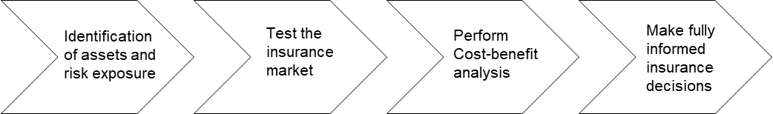
- A state’s access to adequate capital may be demonstrated by referencing the state’s policies to access internal funds, such as deferral of capital expenditure, access to insurance and/or the state’s ability or willingness to borrow.

Commonwealth of Australia, Department of Finance and Deregulation. Review of Insurance Arrangements of State and Territory Governments under the Natural Disaster Relief and Recovery Arrangements Determination 2011. NDRRA Phase 2 Report. September 2012.

